19th Clay Conference in Czech republic

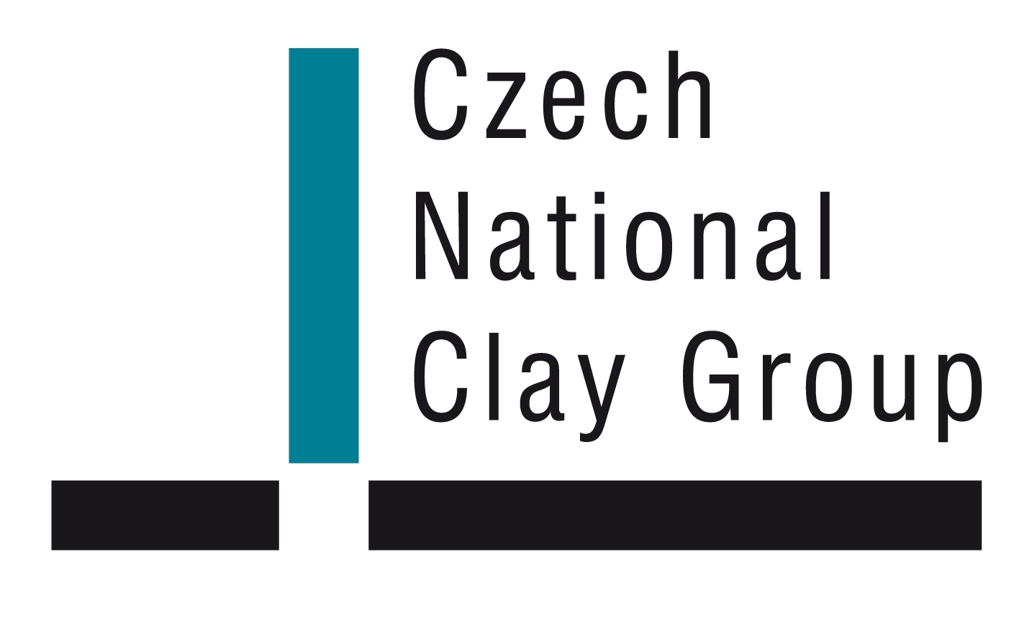

Czech National Clay Group

August 28 - August 31, 2011
Hotel Skalský dvůr
near Bystřice n. Pernštejnem

Second Circular
19th Clay Conference in czech republic

August 28 - August 31, 2011, HOTEL SKALSKÝ DVŮR near BYSTŘICE NAD PERNŠTEJNEM

Czech Republic

Organizing Committee:
Miroslav Pospíšil
Martin Šťastný
Pavel Hájek
Martin Holý
Soňa Jarková
David Koloušek
Jiří Konta
Karel Melka
Josef Mitáš

Scientific committee:
Vlastimil Bílek
Barbora Doušová
Petr Duchek
Vladimír Hanykýř
Peter Komadel
Jiří Konta
Ivan Kraus
Jana Madejová
Petr Martinec
Karel Melka
Iveta Štyriaková
Marta Valášková

Contact address:
RNDr. Miroslav Pospíšil
ČSVVJ
Faculty of Mathematics and Physics
Ke Karlovu 3
12116 Praha 2
tel. +420-221911245, fax: +420-221911249
e-mail: pospisil@karlov.mff.cuni.cz

Important dates:
Jyly 10, 2011 Deadline for abstracts submission. Abstracts of lectures and posters: We thank all participants of the 19th Clay Conference who have submitted their abstracts before deadline.
July 10, 2011 Deadline for receiving binding registration form. Deadline for accommodation booking form. Deadline for the reimbursement of the registration fee and the payment for accommodation.
Jyly 15, 2011 Last day for cancellation of services without reducing payments.
August 28 - September 2, 2011
Submission of manuscripts for the Conference Proceedings.
August 28, 2011 Conference will be officially opened.

General information:
The 19th Clay Conference in Czech republic is organized by the Czech National Clay Group together with Bystřicko a.s., Faculty of Mathematics and Physics, and in co-operation with DIAMO s.p.
Conference site:
The Conferences on Clay Mineralogy and Petrology with international participation have been organized in various sites of the country since 1958. Vysočina will be the host of the Conference in this year. Conference will be held in the building of hotel Skalský dvůr near Bystřice nad Pernštejnem, Lísek 52, 59301 Bystřice nad Pernštejnem.

Conference program:
Themes:
A) Clays in environment
B) Clays in ceramics
C) Clays in building industry
D) Clays in geology
E) Clays in polymers
F) Clays in catalysis
G) Clays in pharmaceutical applications
H) Clays in adsorption and intercalation processes
I) Identification of clay minerals

ORGANIZATION

First day, August 28 (Sunday)
Morning:
Registration
Afternoon:
Opening conference, plenary lectures and general information about uranium mine excursion

August 29 – August 31:
Morning:
1. one group excursion
2. others - lectures
Afternoon:
Lectures or poster session

Excursions:
From Monday to Wendesday or to Thursday:
Excursion to uranium mine for interested person. Limit is 15 participants per 1 excursion and day. Depth of mine is about 1 km, participants obtain certificate confirming a visit of mine.

Languages
Czech, Slovak, English.
Abstracts are available in Czech, Slovak or in English. Contributions to conference proceedings published as a special issue of Acta geodynamika et geomaterialia must be submit in English.

Oral and posters:
The participants will be notified of the enlistment of their contributions in sessions by e-mail. The introductory invited lectures will be presented on 40 to 45 minutes. Each speakers will have 15 minutes for one presentation and 5 minutes for the discussion (PC projector will be available). Posters boards 109 x 120 cm (wide x high) will be exhibited in the adjacent places and will be displayed during the whole time of the conference.

Other activities prepared by the Organizing Committee:
Welcome party, August 28.
Meeting of the Czech National Clay Group, August 29 in the evening.
Concert of sacred songs at subsidiary church of saint Michael archangel in Vítochov, near Bystřice nad Pernštejnem, August 30 after lectures.
Excursion to Pernštejn castle, August 31 afternoon.
Conference dinner, August 30 after concert.

Board
Prices for accommodation in hotels include a breakfast. In conference fee is: welcome party, lunches, dinners and festive dinner.

Registration:
Participants are registered when they fill in the enclosed application form and send it to the Organizing Committee. At the same time it is necessary to pay the registration fee. This fee covers the attendance of scientific sessions, field trip, conference social events (prepared by the Organizing Committee), printing and delivering relevant conference documents (Circulars, Excursion guidebook, List of participants, Book of Abstracts, and Conference Proceedings (Conf. Proc. will be published and distributed after the conference - yr. 2012)).
The registration fee | to July 10, 2011 | after July 10, 2011
Regular participant | 190,- € | 225,- €
Accompanying persons | 90,- € | 105,- €
Students | 160,- € | 170,- €

The completed Binding Registration Form should reach the Organizing Committee by July 10, 2011. It must be accompanied with the payment of the Registration Fee by a bank transfer to the account No. 479112193/0300, BIC: cekoczpp, IBAN: CZ59 0300 0000 0004 7911 2193, symbol account 192011 at ČSOB bank, Na Příkopě 18, 110 00 Prague 1, Czech Republic. Please, write your name on the bank transfer. The participants are required to send these document or their copies to the Organizing Committee.

Accommodation:
Accommodation is reserved in place of action in hotel Skalský dvůr:
Accommodation: 72,- €/double room/night
40,- €/single room/night
In the price of accommodation is breakfast and utilization of sport facilities (tennis and volleyball courts), basin with counter flow, sauna, fitness, and rental of halls.
Payment for the accommodation in hotel together with the registration fee is possible to settle by the bank transfer to the account of CESKA SPOLECNOST PRO VYZKUM A VYUZITI JILU No. 479112193/0300, BIC: cekoczpp, IBAN: CZ59 0300 0000 0004 7911 2193, symbol account 192011 at CSOB, Na Příkopě 18, Prague 1, Czech Republic. Please, write your name on the bank transfer.
Send a copy of your bank transfer to address: pospisil@karlov.mff.cuni.cz or Miroslav Pospíšil, Faculty of Mathematics and Physics, Ke Karlovu 3, 12116 Praha 2, as a proof that the payment has been effected (Fax: + 420 221 911 249). It is supposed that each participant makes a copy of the form for himself.
Closing date for reservations and payments is July 10, 2011. The realization of later orders cannot be guaranteed.
All payments for the Registration fee and Accommodation fees must be free of bank charges to the receiver, i.e. all bank charges for effecting the international money transfer must be covered by the remitter.

Cancellations
It is possible to cancel the registration fee as well as the accommodation with full reimbursement of payments (after subtracting bank charges). Written cancellation must be sent to the Organizing Committee before July 15, 2011. August 15 to September 15, 2011 is 50 percent of all cancelled services and after August 15, 2011 no refund. The conference materials will be sent to the address of the registered participants.

Instruction for authors of abstracts:
Margins (upper margin 50 mm, left margin 25 mm, right margin 25 mm, low margin 25 mm)
TITLE OF ABSTRACT - Times New Roman font, size 14, capital letters bold, lines 1 (align left)
(double blank space)
Authors ^{1) 2) 3)...} Times New Roman font, size 12, normal, lines 1 (align left)
(one blank space)
^{1) 2) 3)...} Organization and addresses, Times New Roman font, size 10, normal, lines 1 (align left)
(double blank space)
Text of abstract, Times New Roman font, size 12, normal, lines 1 (justify to the block)
The abstract written in English language should have an extent of one page A4, text written in format Word version 6.0, 7.0, 97, 2000, 2003 should be submitted on 3,5“ disk 1.44 MB or CD-room and in two copies.
Abstract can be submitted in any of the following formats:
- E-mail attached document;
- E-mail plain text;
- Faxed copy with original and diskette to follow by mail;
- Mailed hard copy.
The order of preference is from 1) to 4)
Instruction for authors of papers:
Margins (the first page upper margin 50 mm and further pages 25 mm at all margins))
TITLE OF PAPERS, Times New Roman font, size 14, capital letters bold, lines 1 (align left)
(double blank space)
Authors ^{1) 2) 3)...} Times New Roman font, size 12, normal, lines 1 (align left)
(one blank space)
^{1) 2) 3)...} Organizations and addresses, Times New Roman font, size 10, normal, lines 1 (align left)
(double blank space)
Text of abstract, Times New Roman font, size 10, normal, lines 1 (justify to the block)
(double blank space)
Text of papers, Times New Roman font, size 12, normal, lines 1,5 (justify to the block)
TITLE OF CHAPTER, Times New Roman font, size 12, capital letters bold, lines 1.5
References should follow this format:
Wanting to support the uniform quotation mode in the European clay literature, we recommend to follow Instructions to authors of the journal of the European Clay Groups CLAY MINERALS, which are given in each number of the journal.
Citation of article in journals -
Brindley G.W., Semples R.E. (1970): Preparation and properties of some hydroxy-aluminium beidellites. Clay minerals, 12, 229-237.
Citation of paper in Symposia -
Mering J., Oberlin A. (1977): The smectites. Pp. 193-229 in The Electron Optical Investigation of Clays (J.A. Gard, editor), Mineralogical Society, London.
Citation of books -
Yariv S., Cross H. (1979): Geochemistry of Colloidal Systems, pp.313-318. Springer-Verlag, Berlin.
Citation of thesis and reports -
Whittle C.K. (1985): Analytical transmission electron microscopy of authigenic chlorites. PhD thesis, Univ. Shefield, UK.
The manuscript written in English language should have an extent around 10 pages A4, text written in format Word version 6.0, 7.0, 97, 2000, 2003 and tables in format Word or Excell version 6.0, 7.0, 97, 2000, 2003 and pictures in graphic format *.PCX, *.TIF, * .JPG, *.BMP, to be processed in Corell Draw 11.0, the manuscript should be submitted on 3.5“ disk 1.44 MB or CD-ROMs and two copies
Binding registrAtion form

The registration form must be delivered by mail or electronically through www.czechclaygroup.cz to the Organizing Committee by July 10, 2011.
First Name: Title:
Surname: Male Female
Institution:
Street: City:
Postal Code: Country:
E-mail: Fax:
Status: Participant students accompanying

I am going to partcipate in:
Welcome party
Field trips
Conference dinner
(all in price of conference registration fee)
tour for accompanyig guests
I have paid: € Conference registration fee

signature
Abstract submission information form
The abstract submission information form must be delivered to the Organizing Committee by July 10, 2011.
Name of presenting author + co-authors:

Title of papers:

Presentation: oral poster
Address: (Street, Postal Code, City, Country):

E-mail, telephone, fax:

I need for the presentation (slide projector, overhead projector, PC projector):

I have interest to publish my paper in the Conference Proceedings volume:

signature
Accommodation booking form

The accommodation booking form must be delivered to the Conference Committee by July 10, 2011.

Hotel Skalský dvůr

Accommodation: 72,- €/double room/night)
40,- €/single room/night
Night 28.08./29.08.2011
Night 29.08./30.08.2011
Night 30.08./31.08.2011
Night 31.08./01.09.2011

I wish to share the double room with

..................................
signature

Address for Correspondence:

ČSVVJ
RNDr. Miroslav Pospíšil, Ph.D.
Univerzita Karlova v Praze
Matematicko-fyzikální fakulta
Ke Karlovu 3, 12116 Praha 2

Tel.: +420-221911245
Fax: +420-221911249
e-mail: pospisil@karlov.mff.cuni.cz

